Mongo API – Client Project

* Start project:

To start the API project type (npm install) (node server.js).

And for client project type (npm install) (npm start).

This Project is about creating a Database of Users and Movies, each User have 0 or many movies. The project will be explained in 2 parts:

* Mongo API:

In this section I created an API to do the following actions:

* + Create User
  + Read one user
  + Read all users
  + Delete user
  + Create movie
  + Read one movie
  + Read all movies
  + Delete movie

This project is an API created with NodeJS and its front created with ReactJS.

Let’s start with the API, after finishing routes and controllers I created fake data to test the API and to do that I used a package called: casual, it allows me to create users and movies whenever the server restart. And the photo at the bottom show how it has been written in code.

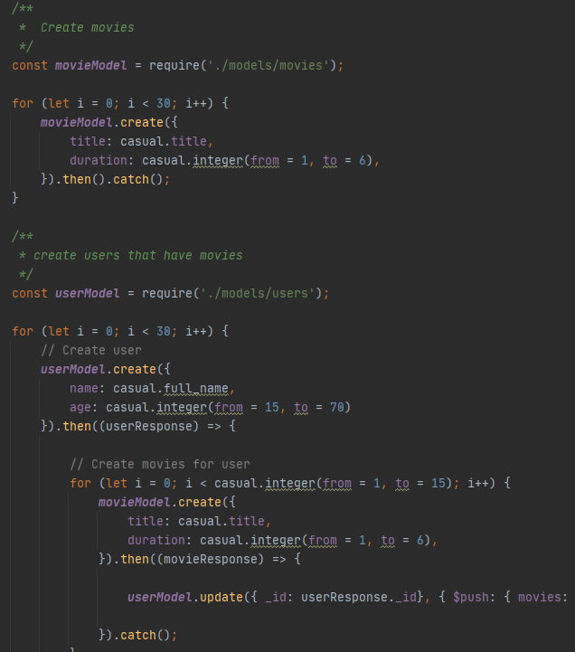

Next, I used Postman to test if the routers really work and here are the results of those tests:

Create user

Read One User

Delete User

Read all users

Create Movie

Read one movie

Delete movie

Read all movies

I created a simple front to display users and movies in two different tables with the possibility to

* Create a user
* Display a user by his ID
* Display Movies of a user
* Delete a user

Some captures for the front :

Users Page

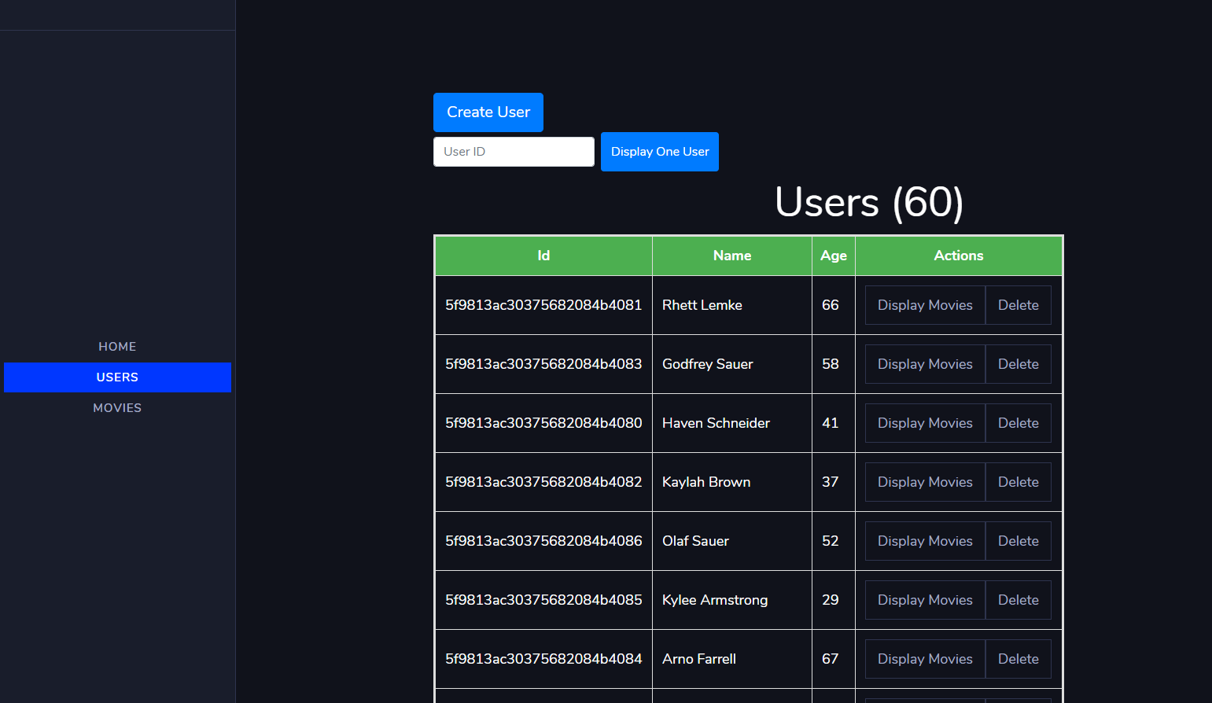

Movies page

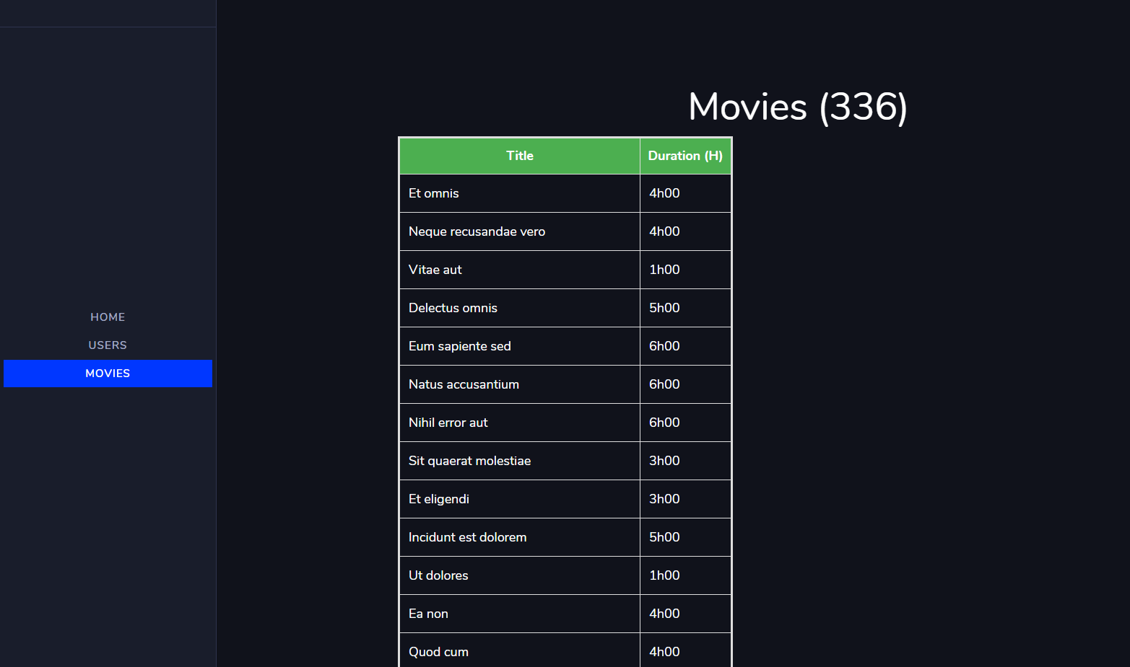

Create a user

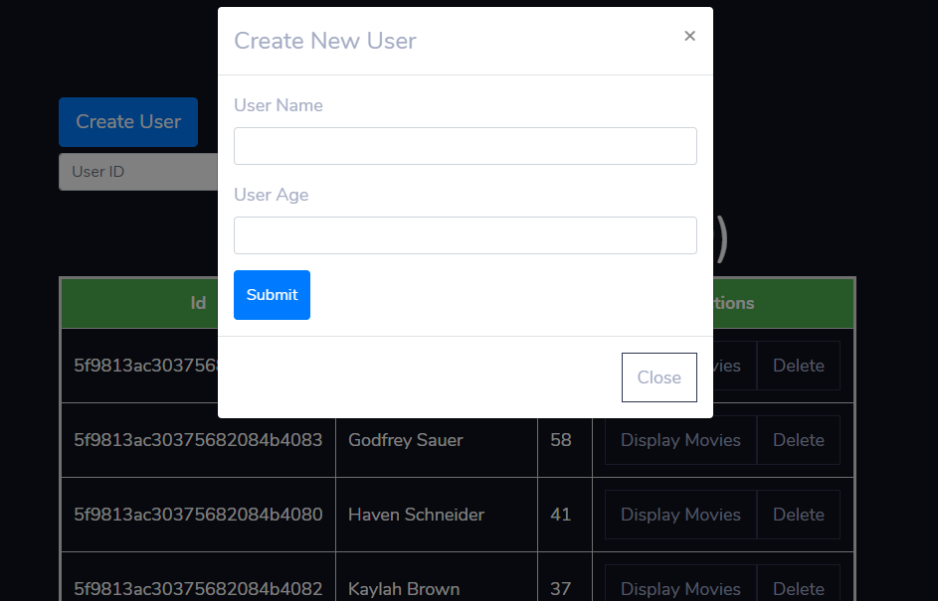

Display a user

